fo|ky; ifjokj ifjp;
Ø-l- | dkfeZd dk uke | ;ksX;rk | Qksu ua- | bZ esy | QksVks
1 | Jh ckcwyky xgyksr | M.Sc. (Maths)  B.Ed | 7726006890 | bagehlot11@gmail.com | 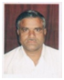
2 | Jherh laxhrk pkSjfM+;k | M.A. B.Ed | 7726006884 | Choradiasangeeta001@gmail.com | 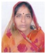
3 | Jh lksgu yky xkSM+ | M.A. B.Ed | 9983900577 |  | 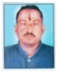
4 | Jh ;ksxsUnz dqekj 'kekZ | B.A., B. Ed | 9680972284 | yogendraksharma62@gmail.com | 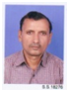
5 | Jh izoh.k dqekj ekFkqj | B.Sc. B.Ed | 9460552275 | aayushmathuryoyo@gmail.com | 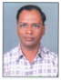
6 | Jh jes'k tkafxM+ | B.A., B. Ed | 9460251305 | rameshjangid472@gmail.com | 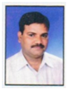
7 | Jh t;izdk'k nos | B.A. STC | 02912790137 |  | 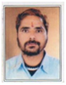
10 | Jherh vukfedk | M.A., B. Ed | 9414209613 |  | 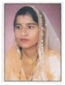
11 | Jherh mfeZyk nos | B.A., B. Ed | 9772068568 |  | 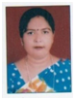
12 | Jh ftrsUnz dqekj jkadkor | M.A., B. Ed, PGDCA | 8233268950 | jkrankawat21e@gmail.com | 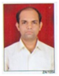
13 | Jherh ljkst ‘kekZ | B.A. B.E.d | 9462075111 | sarojsharma01976@gmail.com | 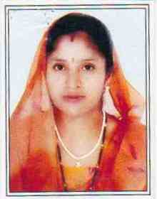
14 | Jherh xhrk | B.A. S.T.C. | 9784863769 |  | 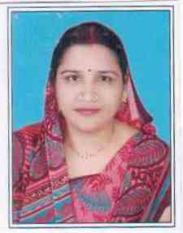
15 | Jh yksds’k jkoy | M.A., B.Ed |  |  | 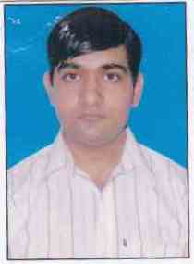
16 | Jh Hktuyky iaokj | B.A., S.T.C. | 9166168331 | bhajanlalpanwar699@gmail.com | 
17 | Jherh lhek nS;k | B.C.A., S.T.C | 9694166106 |  | 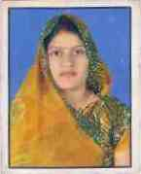
17 | Jh egsUnz flag | M.Sc., B.Ed. | 9414412212 | mahi.benan@gmail.com | 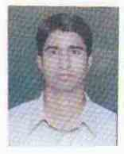
18 | Jh foØe nsFkk | M.A., B.Ed | 9414333337 | singh.vikram1111@gmail.com | 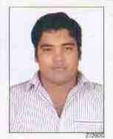
19 | Jh Hkwjkjke | M.A., B.Ed. | 9462601619 | bhoora438@gmail.com | 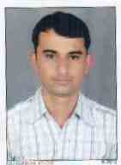
20 | Jherh ehuy ‘kekZ | B.A., B.Ed | 7790887449 | meenu.rakesh102@gmail.com | 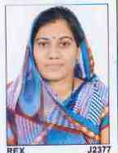
20 | Jh eukst iqjksfgr | B.Com | 7727010423 | purohitmanoj1970@gmail.com | 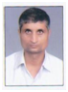
21 | Jherh rkjk xgyksr | Vth | 7790929589 |  | 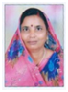
22 | Jh egs'k pkSgku | Vth | 8385965172 |  | 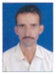
LFkkuh; mi&lfefr ifjp;
Ø- | uke | in | dk;Z {ks= | irk o bZ&esy | Qksu ua-
1 | Jh ;ksxs'k ekgs'ojh | v/;{k | futh O;olk; | fnfXot; uxj] 9413329749 info@surfaceint.com | 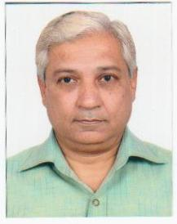
2 | Jh xkSre lkyspk | mik/;{k | futh O;olk; | uUnuou xzhUl] 9324246660 | 
3 | Jh v'kksd xgyksr | O;oLFkkid | futh O;olk; | [ksesa dk dqvkW] 9784003524 marashokgehlot@gmail.com | 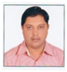
4 | Jh lquhy lkyspk | dks"kk/;{k | futh O;olk; | xqykc uxj] 9828031032 sunilsalecha@yahoo.co.in | 
5 | Jh jktsUnz flag | ‘kSf{kd izHkkjh | lsokfuo`r v/;kid | 23 ls- pkS-gk-cksMZ] 9887980601 rajsinghka@yahoo.com
6 | Jh iq[kjkt lk¡[kyk | fodkl izeq[k | futh O;olk; | fouk;d uxj] 9414919948 | 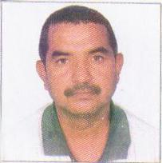
7 | Jh mnkjke iVsy | fodkl izeq[k | futh O;olk; | lhrkjke uxj] 9414135812 | 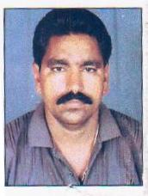
8 | Jh jkorkjke chatkfj;k | lnL; | ,MoksdsV | chatkfj;k uxj] 9413304441
9 | Jh v'kksd dqekj 'kekZ | lnL; | futh O;olk; | ;wvkbZVh dkWyksuh] 9414115753
10 | Jh ‘kkfUr izlkn tkykuh | lnL; | ,yvkbZlh | vxzslu uxj] 9414301355
11 | MkW- deys'k pkS/kjh | lnL; | fpfdRld | ds’ko uxj] 9414602098
12 | Jh y{e.k xgyksr | lnL; | lh, | [ksesa dk dqvkW] 9828430329 | 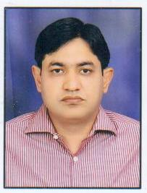
13 | Jh jes'k [k=h | lnL; | Hkwty foHkkx | xk;=h uxj] 9414477157 rkkhatri1234@yahoo.co.in | 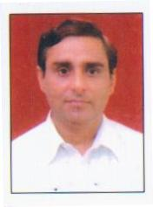
14 | Jh fd'ku jkekor | lnL; | iky ckykth iqtkjh | iky ckykth efUnj]  9799597995
15 | Jh ckcwjke fo’uksbZ | lnL; | VªkaliksVZ | vfHk”ksd uxj] 9214588655
16 | Jh ujirflag jktiqjksfgr | lnL; | fe”Bku izfr”Bku | xk;=h uxj] 9414132970
17 | Jh eksguflag | lnL; | gSf.MØk¶V | ;wvkbZVh dkWyksuh] 9602236916
18 | Jh x.ks’k pkS/kjh | lnL; | v/;kid | Fkksfj;ksa dh <k.kh] 9982893052
19 | Jh Hkh;kjke iVsy | lnL; | esfMdkst | ckykth uxj] 9983384501
20 | Jh guqekujke ykSgkj | lnL; | gSf.MxzkQ | fouk;d uxj] 9413572794
21 | Jh nsokjke dqekor | lnL; | futh O;olk; | iky xk¡o] 9468843337
22 | Jherh dfork iaokj | lnL; | x`g.kh | vfHk”ksd uxj] 9252180875
23 | Jherh dapu djok | lnL; | futh O;olk; | ds’ko uxj] 9929992042
24 | Jherh uhrk iaokj | lnL; | gSf.MØk¶V | izse uxj] 9887461886
25 | Jherh laxhrk pkSjfM+;k | insu lnL; | iz/kkukpk;Z | 15 ls- pkS-gk-cksMZ] 7726006884 Choradiasangeeta001@gmail.com
26 | Jh ckcwyky xgyksr | insu lfpo | iz/kkukpk;Z | pSuiqjk] e.Mksj] 7726006890 bagehlot11@gmail.com
iwoZ Nk= ifj"kn~ dk;Zdkfj.kh

Ø-la- | uke | Ikn | irk | nwjHkk"kkad
 |  |  |  | ?kj | Pky
1- | cfgu [kq'kcw 'kekZ | v/;{k | pkSikluh xkWo] igyh xyh | 2760933 | 9414473026
2- | HkS;k ek/ko vks>k | mik/;{k | jke}kjs ds ikl lwjlkxj |  | 9460661176
3- | HkS;k lqn'kZu tkafxM+ | dks"kk/;{k | 74]'kqHke QkWeZ iky jksM+ | 2766072 | 9461647894
4- | HkS;k Kkus'oj xgyksr | lfpo | 102 ]fjM+ey uxj iky jksM+ |  | 9529092261
5- | cfgu o"kkZ fiM+ok | lfpo | 45] foosdkuUn dkWyksuh |  | 8560076511
6- | HkS;k vfHk"ksd iVsy | lEidZ izeq[k | iVsy Hkou] [kses dk dqvka | 8561835882 | 9309209997
7- | HkS;k lw;Z izrki flag | lEidZ izeq[k | 23@157 pkSikluh gk-cksM+Z | 9309330779 | 8963038821
8- | Jh jes'k tkafxM+ | fo|ky;  izfrfuf/k | lh&3 elwfj;k tks/kiqj | 8852878008 | 9460251305
9- | Jhjkefd'kksj vfXugks=h | fo|ky;  izfrfuf/k | 19@205 pkSikluh gk-cksMZ |  | 9983974764
10- | HkS;k ;ksxsUnz jlhM+ | lnL; | 84]ckck jkenso jksM+ | 2771065 | 7742221222
11- | cfgu 'osrk xks;y | lnL; | 191]lqHkk"k uxj ikyjksM+ | 3206333 | 9529755535
12- | HkS;k vjfoUn ukgVk | lnL; | 46]dkfUr uxj iky jksM+ | 9462097947 | 9024319512
13- | cfgu fiz;k xxZ | lnL; | 47]vxzlsu uxj iky jksM+ | 2788057 | 9929375888
14 | HkS;k xksfoUn “kekZ | lnL; | 20]*chs*Jfediqjk]elwfj;k |  | 9314719973
15- | HkS;k iou tkafxM+ | lnL; | 49]Jh[kksfM+;kj uxj [kses dk dqvka | 8562860751 | 8562860751
16- | HkS;k johUnz flag jkBkSM+ | lnL; | 'kksHkkorksa dh <k.kh]iky jksM+ | 9782317180 | 9782317180
17- | HkS;k dq'kykjke | lnL; | lsok/kke Nk=kokl iky jksM+ | 8947821662 | 9549507630
18- | HkS;k lwjkjke | lnL; | lsok/kke Nk=kokl iky jksM+ | 8947821662 | 9549507630
19- | HkS;k v'kksd flag | lnL; | xk;=h uxj iky jksM+ |  | 8233347369
20- | HkS;k 'kSysUnz flag jkBkSM+ | lnL; | 1] jfo uxj iky jksM+ | 9784330557 | 9950893166
21- | HkS;k vk'kh"k ekFkqj | lnL; | 25 ch-1] pkSikluh gk- cksM+Z |  | 9001050107
22- | HkS;k jk?ko vxzoky | lnL; | vxzlsu uxj iky jksM+ |  | 8829888939
23- | cfgu vafdrk xks;y | lnL; | 191]lqHkk"k uxj ikyjksM+ | 3206333 | 9529755535
24- | HkS;k gjh'k [k=h | lnL; | 14&ch] lqHkk"k uxj iky jksM+ | 2787222 | 7677099922
25- | HkS;k fnyhi flag | lnL; | 53]xksyhekj xkMZu22xksnke t;iqj | 9680144407 | 9680144407
26- | HkS-n'kjFk flag jktiqjksfgr | lnL; | 246]lqHkk"k uxj] iky jksM+ | 9414132199
27- | HkS;k egsUnz lsaoj | lnL; | 24]xk;=h uxj iky jksM+ |  | 9782300352
28- | HkS;k yfyr Hkwr | lnL; | 176]Jh d`".kk uxj iky jksM+ | 2716178 | 8890094079
29- | HkS;k r#.k ikjhd | lnL; | 178@ch lsDlu 2 elwfj;k | 2770444 | 8290164477

